Answers to the Christmas Quiz 2002

The response to the Christmas Quiz 2002 was very encouraging. We are pleased to announce the two winners, both of whom scored full marks, as follows:

Fong Man Wah Danny
Chan Yat Ying

Our warmest congratulations to both. They will each receive the prize of a set of three uncut $10 notes

The answers to the Christmas Quiz are:

Chart 1

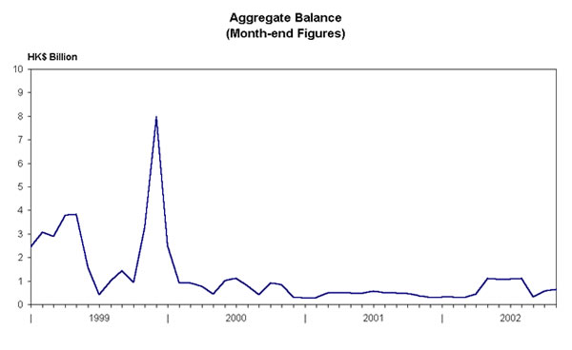

Chart 2
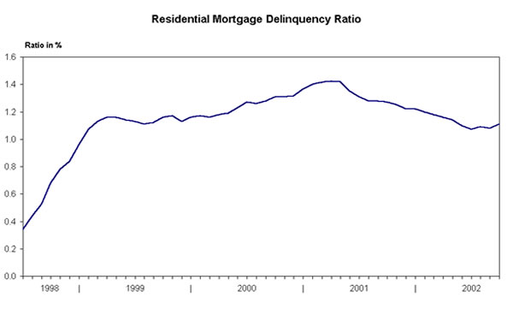

Chart 3
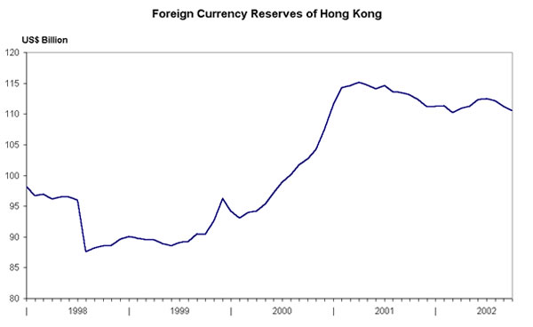

Chart 4

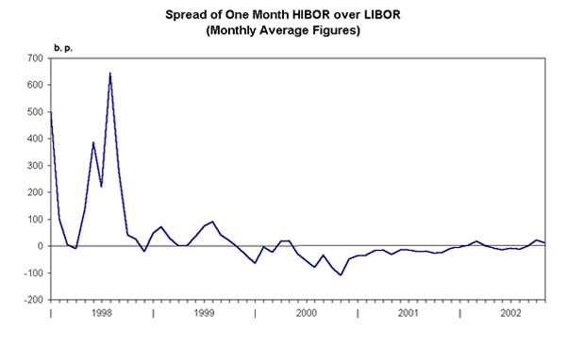

Chart 5
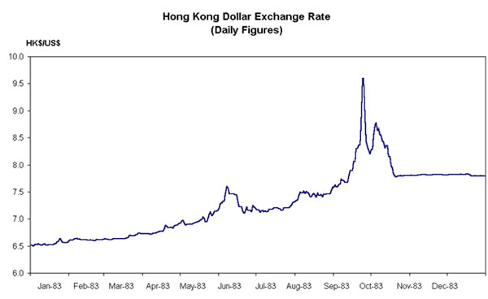

Chart 6

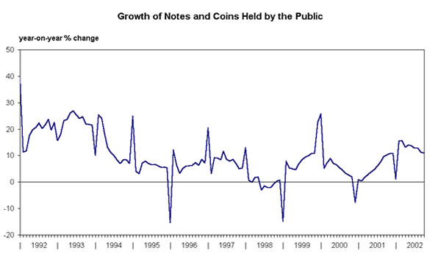

Chart 7
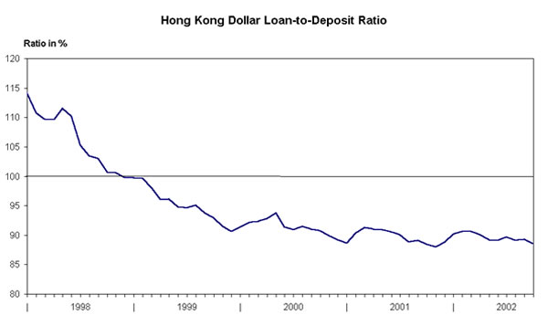

Chart 8

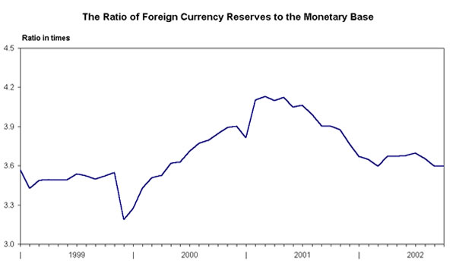

Chart 9

