RARE AND CURIOUS COINS

Some of the coins in your pocket or purse may be rarer than you might think.

My earlier Viewpoint article about coin designs unexpectedly attracted a good deal of attention among readers. I also received a number of sympathetic messages in response to my “confession” to being the culprit behind the design of the Bauhinia coins. This is perhaps an indication that there is quite a lot of community interest in the less esoteric aspects of our currency. So let me disclose more, if only for the benefit of those, like me, who are in the habit of collecting coins.

First, some basic information. The last year of issue of the various denominations of the Queen’s Head coins and the first year of issue of the Bauhinia coins are as follows:

Denominations | Last year of issue of the Queen’s Head coins | First year of issue of the Bauhinia coins
$10 | (never issued) | 1994
$5 | 1989 | 1993
$2 | 1992 | 1993
$1 | 1992 | 1993
50¢ | 1990 | 1993
20¢ | 1991 | 1993
10¢ | 1992 | 1994
5¢ | 1979 | (not replaced)

The first issues of the Bauhinia coins are, of course, in abundant supply, but the last issues of the Queen’s Head coins, and indeed the Queen’s Head coins of any year, have become quite rare. This is because, in accordance with the Sino-British Joint Declaration, they have been “progressively replaced and withdrawn from circulation”. Where they are still out there in the hands of members of the public, they have become collectors’ items and are rarely circulated.

There are two further matters of interest to the serious coin collector. If you find a 1993 one dollar Bauhinia coin that can be picked up by a magnet, hold on to it. Only one in every hundred one dollar Bauhinia coins has this quality. This is because an attempt was made in that year to use a more economical, steel plated coin for the one dollar denomination, as against the more expensive cupro-nickel coin that has been in circulation since 1960. In the end, we decided against the use of steel plating for the one dollar coin, but not until after the issue of a certain number of these coins.

Two even rarer items are the 1993 ten dollar Bauhinia coin and the 1993 ten cent Bauhinia coin (see photographs below). As the above table indicates, neither of these coins was officially issued until 1994. However, a number of these coins bearing the year 1993 were minted, partly for the purpose of testing and partly for inclusion in presentation sets of Hong Kong coins for that year. It is likely that some of these 1993 coins have gone into general circulation: for example, the presentation sets for that year may well have been broken up and spent by the less avid coin collectors among us who received them as gifts. Over the years, I have checked every ten dollar and ten cent coin I have come across, but I have still not had the good fortune to find any that bear the year 1993. I wonder if readers of this column have had better luck.

Joseph Yam
10 February 2000

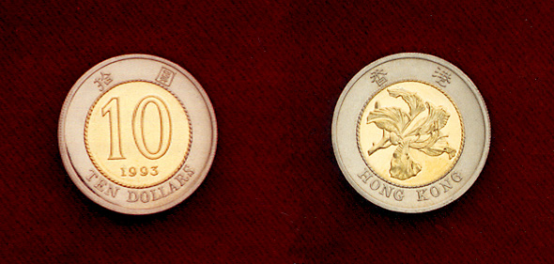
The 1993 ten dollar coin
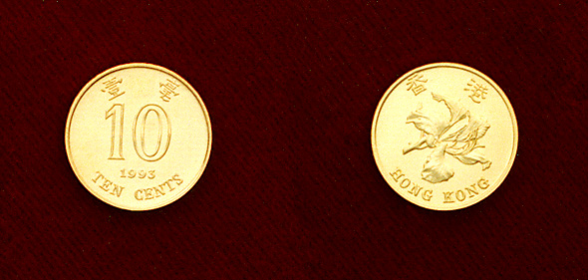

The 1993 ten cent coin

