Mortgage loans in negative equity
The recent increase in the number of negative-equity mortgages will not affect the stability of the banking sector.

The last time I briefed the Legislative Council Financial Affairs Panel on the work of the HKMA, I drew attention to the small increase just then recorded in the number of negative-equity mortgages on the books of licensed banks in the third quarter of 2005. Residential property prices had eased somewhat during that quarter so that an increase in negative-equity mortgages was not unexpected. This showed up in the numbers quite quickly and we therefore decided to look into the matter in greater detail, with the help of a sample of banks responsible for about 70% of the residential mortgage market. The results, based on information provided by these banks in a one-off exercise, are shown in charts 1 to 4 attached.

While the results are interesting, particularly those relating negative-equity mortgages at the end of September last year to the size of properties, the level of household income and the year in which the mortgages were granted, they do not throw any light on the apparently greater sensitivity of the overall number to the movement in residential property prices. I of course have great sympathy for people who find themselves in negative-equity; servicing a mortgage that exceeds the current value of the property is bound to be distressing, especially when the property is the family home. As banking supervisor, the HKMA’s concern has to be the likely significance of negative-equity mortgages for the quality of the loan book of banks. We therefore organised more extensive discussions with a few banks that have experienced increases in such mortgages recently and arrived at the following explanation, which should enrich the interpretation of the figures in future.

To simplify the matter, it would be useful to consider two different purchases of residential property in which both buyers obtained 90% finance. In case one, the bank lent 70% and there was a top-up loan of 20% from the developer. In case two, the bank lent 90%, but assumed, as required by us, only a 70% risk by arranging insurance for the repayment of the other 20%. Clearly, although in both cases the banks concerned are exposed to only 70% of the purchase value of the property, case one has a 30% cushion and case two has only a 10% cushion against a fall in residential property prices before being classified by the banks as a negative-equity mortgage. Obviously, from the point of view of the borrowers, both of them would be servicing negative-equity mortgages if property prices fell by more than 10%, regardless of how their mortgages are classified by the banks.

The introduction of mortgage insurance in Hong Kong has enabled banks to lend more than 70% of the value of the property (say 90%, although we have not yet been able to establish what the norm is) while taking only 70% risk. To make it convenient for borrowers, banks increasingly provide a one-stop service and lend, say, 90% and spread the risk in excess of 70% by arranging mortgage insurance for the borrower and charging him accordingly, either separately or by adjusting the mortgage rate for the loan as a whole. It is this change of practice that has made the negative-equity mortgage numbers that we compile more sensitive to changes in residential property prices. But the exposure of the banks to the residential property market, through extending mortgages, has not changed in proportion. The risks to the banks remain well managed under the 70% loan-to-valuation guideline, although it should be more appropriately called the risk-to-valuation guideline. So, if we see further increases in the number of negative-equity mortgages on the books of the banks, this does not necessarily mean a corresponding deterioration in the quality of the banks’ mortgage loan books. Insofar as the burden on the borrowers is concerned, the number has, nevertheless, become a more realistic measure.

I think it is important to keep the issue of negative-equity mortgages in perspective. The HKMA started tracking the numbers of such mortgages in September 2001. At the peak in June 2003, there were about 106,000 with $165 billion outstanding. In September 2005 there were about 9,000 with $16 billion outstanding, a fall of 91% as shown in chart 5 attached. In that context, the increase of 300 in the third quarter of 2005 does not look alarming.

Joseph Yam
12 January 2006
Chart 1
Chart 2

Chart 3

Chart 4
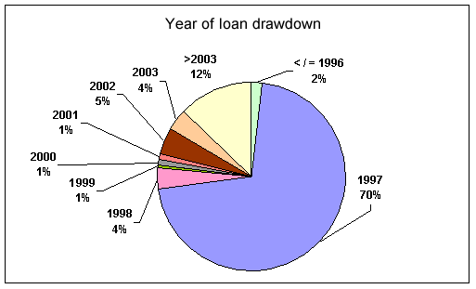

Chart 5

