Christmas Quiz 2004

This year’s Christmas Quiz (the sixth since Viewpoint began in 1999) takes the form of a history exam on Hong Kong currency. The first part shows a few of the people – real and imaginary – who have appeared on certain Hong Kong banknotes and currency notes during the last century. All you have to do is to match the images with the corresponding notes. The second part of the quiz contains questions about currency and daily life in Hong Kong history. Some of the answers in this quiz (but not necessary all of them) can be found in our Information Centre. Readers are welcome to visit the Centre and dig up the correct answers.

Once you have supplied your answers, fill in your personal particulars, and press the "submit" button underneath. Please send in your answers before midnight on Sunday 2 January 2005 (Hong Kong time). Alternatively, you may send your answers to us by fax (852) 2509-9159, or post them (or even deliver them personally) to our Information Centre. Up to three winners will be drawn if more than one set of correct answers is received. The winners will each receive a small prize.
Good luck! And a very happy Christmas to all of you.

Joseph Yam
23 December 2004
Part I

Match the numbers against the images with the corresponding notes.
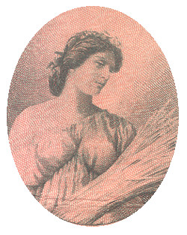 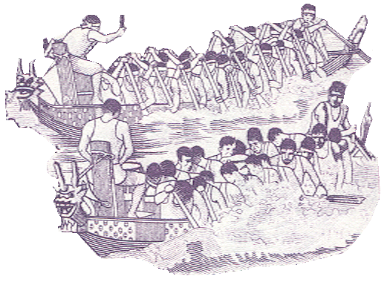
1. Ceres, the Roman harvest goddess 2. Dragon boat racers

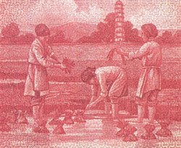 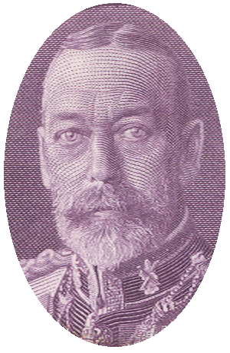
3. Women cultivating rice 4. King George V of the United Kingdom

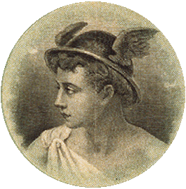
5. Mercury, the Roman messenger god

Notes:
( ) The Hong Kong and Shanghai Banking Corporation $10 (1927)
( ) The Chartered Bank $10 (1931)
( ) Mercantile Bank Limited $10 (1912)
( ) The Hong Kong and Shanghai Banking Corporation Limited $50 (1993)
( ) Hong Kong Government $1 (1935)
Part II

6. When was Hong Kong’s first banknote issued?
(a) 1845 (b) 1864 (c) 1879

7. Where was the former Hong Kong Mint located?
(a) Tai Po (b) Causeway Bay (c) Tsim Sha Tsui

8. Which is the lowest denomination coin ever issued in Hong Kong?
(a) 1 mil (b) 1 penny (c) 1 cent

9. When did the Government demonetise the 1 cent note?
(a) 1993 (b) 1995 (c) 1997

10. Which was the first note-issuing bank in Hong Kong?
(a) The Oriental Bank Corporation
(b) The Chartered Bank of India, Australia and China
(c) The Chartered Mercantile Bank of India, London and China

11. How many bowls of wonton noodles could a HK$10 banknote buy in the 1950s?
(a) 30 (b) 40 (c) 50

12. Which of the following has never been legal tender in Hong Kong?
(a) Spanish silver dollar (b) Indian rupee (c) Dutch guilder

13. When was the first HK$1 coin issued?
(a) 1866 (b) 1926 (c) 1960

14. How many catties of rice could a HK$100 banknote buy in the 1960s?
(a) 200 (b) 300 (c) 400

15. Which of the following denominations of banknotes has never been issued in Hong Kong?
(a) $2 (b) $5 (c) $25

Name: _______________________
Email: _______________________
Contact number: _______________

