BAUHINIA COINS

The dull and unattractive coins of Hong Kong hardly befit Hong Kong’s status as an international financial centre. Joseph Yam explains his role in their design.

I have another confession to make. If readers examine the design of our coins they will find it, at best, unattractive and unremarkable. Those with any artistic sense might even think it repulsive. I am the one to blame for this sorry state. Yes, the coins were designed by me and I am sorry that users have to put up with them every day. But it was the best design that I could come up with during the planning leading to the introduction of the coins in 1993.

There was a good reason for my taking on this responsibility at the time – albeit with the greatest reluctance. The Sino-British Joint Declaration specifies that “Hong Kong currency bearing references inappropriate to the status of Hong Kong as a Special Administrative Region of the People’s Republic of China shall be progressively replaced and withdrawn from circulation”. It would obviously have been inappropriate, on the Handover on 1 July 1997, to find the coins of Hong Kong all bearing the portrait of the Queen. And it would not have been possible for all the coins to be changed overnight. Even if we could have managed to mint all the required coins and have them ready for distribution at midnight of 30 June 1997, there would have been so much disruption and inconvenience to everybody. This would hardly have been conducive to a smooth transition.

The practical solution was instead to replace the coins bearing the portrait of the Queen well before the Handover. Herein lay a number of further difficulties. First, coins are considered an important badge of sovereignty. To give up the Queen’s portrait well before the actual Handover was not something trivial. Secondly, it would have been equally inappropriate to have designs reflecting Hong Kong’s status as a Special Administrative Region introduced for circulation before the Handover. Thirdly, it would have been impossible to have all the coins replaced by 1 July 1997, no matter how early we started. Fourthly, if the coins, and indeed the banknotes as well, had to be demonetised, there might be the risk of undermining confidence in the currency, however remote this possibility might be. Fifthly, the currency had always been a highly sensitive subject requiring the utmost caution in handling.

This therefore was a matter that had to be dealt with in strictest confidence involving the sovereign powers. The Sino-British negotiations on this matter were, thankfully, very smooth. There was a high degree of trust and co-operation in approaching this, as there was in other monetary issues generally. Agreement was arrived at quickly to introduce as soon as possible a politically neutral design that could ride on the monetary “through train”. This would enable the old design coins with the portrait of the Queen to be progressively replaced by the new design coins and withdrawn from circulation without the need to force them out of circulation by demonetising them.

The remaining task was to come up with the politically neutral design. But the confidential nature of this matter did not allow the appointment of an artist, and so the task was given to yours truly. I obtained a number of photographs of the bauhinia from the Information Services Department on the pretence that I was designing the logo for the HKMA soon to be established then. For the Chinese characters, I copied the relevant ones myself from a piece of calligraphy I commissioned on a passage containing those characters. It was then a simple scissors and paste job that a primary school child would find easy. (The photographs and calligraphy used are reproduced in the illustrations attached at the end of this article)

So there you are – coins of a design hardly befitting the status of Hong Kong as an international financial centre. And for this I would like to offer my belated apologies to the people of Hong Kong. My only mitigating circumstance is that the designs have had the approval of the two sovereign states. The withdrawal of the coins with the portrait of the Queen was faster than I had expected because, surprisingly to me, they became very popular collectors’ items.

Readers may, however, notice that there was a set of commemorative coins issued for collection as well as circulation on the occasion of the Handover. The designs were of a much higher quality, being the work of Lady Haddon-Cave, who also designed the series of twelve Lunar New Year $1,000 gold coins and the two Queen’s visit coins issued during the period from 1975 to 1987. Perhaps it’s time to review the designs of our circulation coins soon, if only to make me feel less guilty.

Joseph Yam

18 November 1999
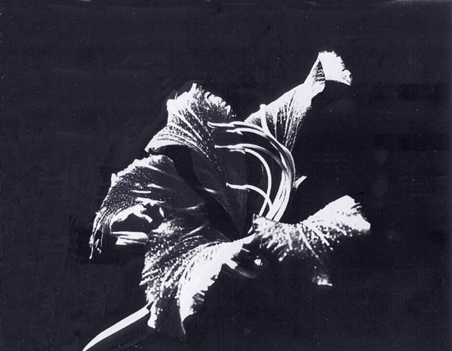
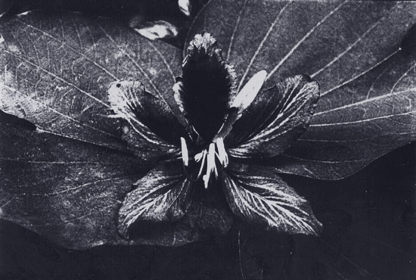

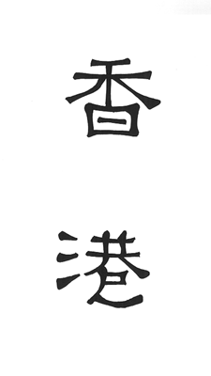 | 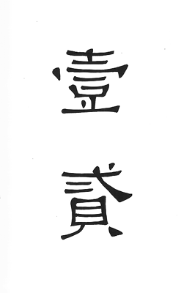
(Hong, Kong) | (One, Two)

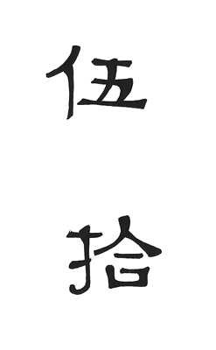 | 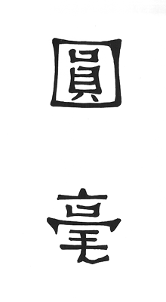
(Five, Ten) | (Dollar, Ten cents)

