Annex

2010 New Series Hong Kong Banknotes
Designs of $500 Banknotes

Standard Chartered Bank (Hong Kong) Limited

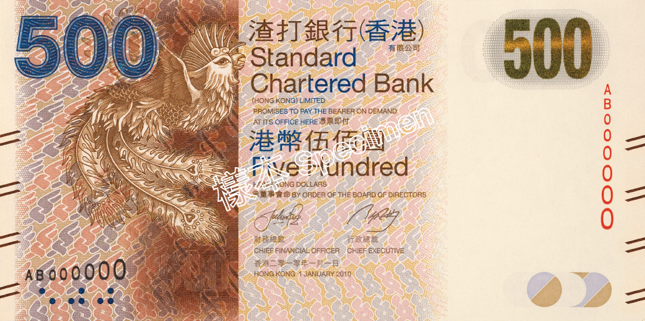 | 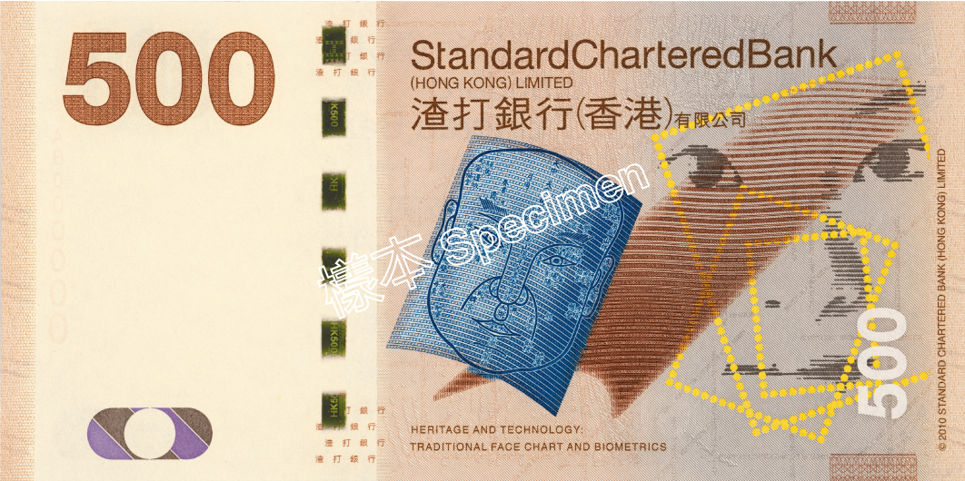
Front | Back

The Hongkong and Shanghai Banking Corporation Limited

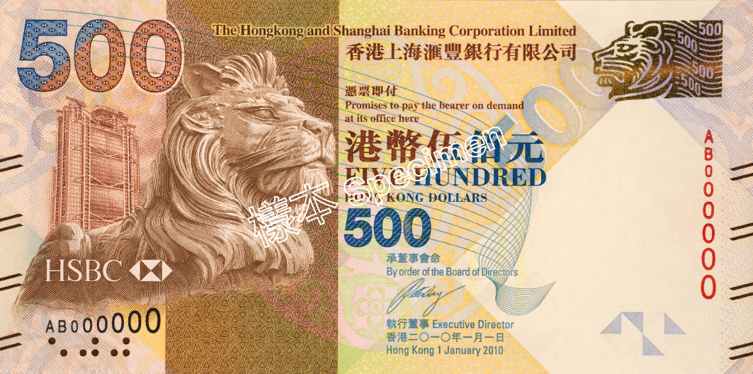 | 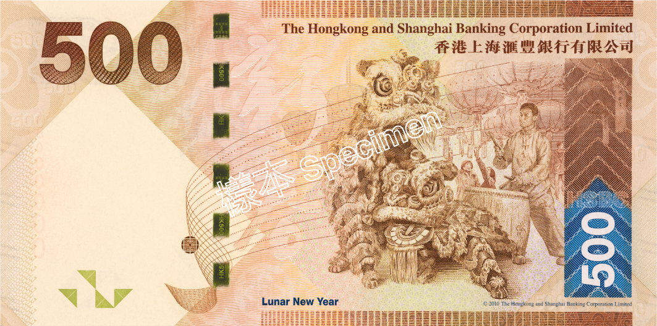
Front | Back

Bank of China (Hong Kong) Limited

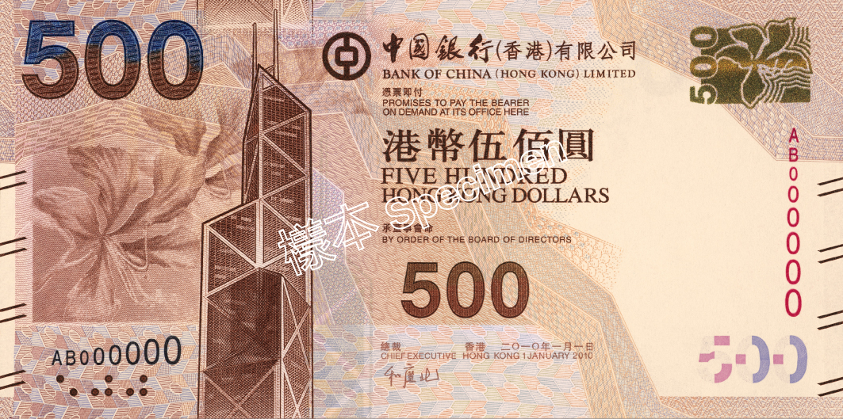 | 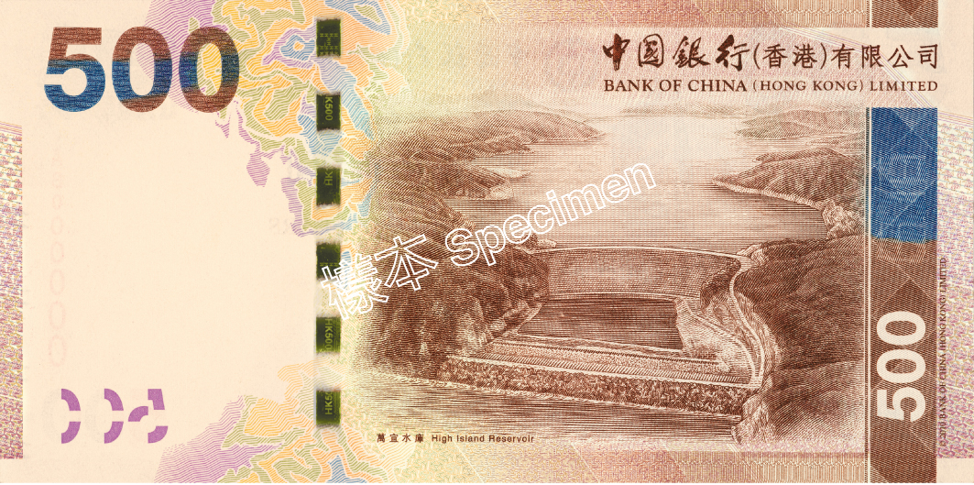
Front | Back

Note to Editor:
Should you wish to reproduce images of the above banknotes, you are required to strictly observe the requirement that the reproduced images, either in full or in part, in your publication must at least be 25%, either smaller or larger, than the corresponding linear size of the actual banknote (158mmW x 79mmH). Failing to observe such requirement may render you liable to prosecution under section 103 of the Crimes Ordinance.

